

# 

# **DEPARTMENT OF COMPUTER SCIENCE AND ENGINEERING**

**CSC3215 – Mobile Application Development**

**Laboratory**

## Name :

RRN :

Semester & Section : VI Semester – A Section



**BONAFIDE CERTIFICATE**

Certified this is the Bonafide record of the work done by **D. INAMUR RAHMAN** Register No. **200071601029** of **VI** Semester **B. Tech- Computer Science and Engineering** in the **CSC3215-MobileIApplication Development Laboratory** during the year **2023.**

Course Faculty Head of the Department

Date:

Submitted for the Practical Examination held on ___________

Examiner



Name of the Student :

RRN :

Name of the faculty :

Department of the Student : Computer Science & Engineering.

Semester from : January 2023 – May 2023

Class &Section : III year – VI Semester – A

Course Code : CSC3215

Course Name : Mobile Application

Laboratory



**1) Course Title**: Mobile Application Development Lab **5) Semester:** VI

**2) Course Code:** CSC 3215 **6) Academic year:** 2022 – 2023

**3) Course Faculty:** Dr. I. Karthiga **7) Department:** B.Tech CSE A

**4) Theory/Practical:** Laboratory **8) No. of Credits:** 1

**INDEX**

|  |  |  |  |  |  |  |  |  |  |
| --- | --- | --- | --- | --- | --- | --- | --- | --- | --- |
| **S.No** | **Date** | **Title** | **Page No.** | **Aim & Procedure**  **(10)** | **Code**  **(15)** | **Output**  **&**  **Result**  **(15)** | **Viva**  **(10)** | **Total**  **(50)** | **Faculty Sign** |
| **1.** |  | How to Install Android Studio |  |  |  |  |  |  |  |
| **2.** |  | Develop an application that uses GUI components, Font and Colors |  |  |  |  |  |  |  |
| **3.** |  | Develop an application that uses Layout Managers, event listeners |  |  |  |  |  |  |  |
| **4.** |  | Develop a native calculator application |  |  |  |  |  |  |  |
| **5.** |  | Write an application that draws basic graphical primitives on the screen |  |  |  |  |  |  |  |
| **6.** |  | Develop an application that makes use of the database. |  |  |  |  |  |  |  |
| **7.** |  | Develop an application that makes use of RSS Feed. |  |  |  |  |  |  |  |
| **8.** |  | Implement an application that implements multi-threading |  |  |  |  |  |  |  |
| **9.** |  | Develop a native application that uses GPS location information |  |  |  |  |  |  |  |
| **10.** |  | Implement an application that creates an alert |  |  |  |  |  |  |  |
| **11.** |  | Mini- Project |  |  |  |  |  |  |  |

Ex no : 01 **How To Install Android Studio**

Date :

**Introduction**

Android is an Operating System for mobile devices developed by Google in 2007, which is built upon a Linux kernel. Android competes with Apple's iOS (for iPhone/iPad), Microsoft's Windows Phone, and many other proprietary mobile OS es. The latest Android supports Phone/Tablet, TV, Wear (watch and glass), Automobile and Internet of things (IoT).

**Android Platform**

Android is based on Linux with a set of native core C/C++ libraries. Android applications are written in Java. However, they run on Android's own Java Virtual Machine, called Dalvik Virtual Machine (DVM) (instead of JDK's JVM) which is optimized to operate on the small and mobile devices.

In May 2017, Google announced support for a new Kotlin programming language. As you are familiar with Java, you probably should start in Java (many of the examples out there are written in Java), and then move into Kotlin. Kotlin will not be discussed in this article.

The mother site for Android is https://[www.android.com.](http://www.android.com/) For programmers and developers, visit https://developer.android.com to download the SDK, Android Training, API Guides and API documentation.

**Installing "Android Studio IDE" and "Android SDK"**

* Installing Android software is probably the most challenging part of this project. It takes times - from 30 minutes to n hours to forever - depending on your luck, your programming knowledge, and your PC.
* You probably need a fairly decent PC (with 8GB RAM) and 10GB of free disk space to run the Android emulator!!! Running on "actual" Android phone/tablet requires much lesser resources.

**Step 0: Pre-Installation Check List**

* + Before installing Android SDK, you need to install Java Development Kit (JDK). Read "How to install JDK". Ensure that your JDK is at or above 1.8. You can check your JDK version with command "javac -version" (compiler) and "java -version"(runtime).
  + Uninstall older version(s) of "Android Studio" and "Android SDK", if any.
  + The installation and many operations take a LONG time to complete. Do NOT stare at your screen or at the ceiling. Browse through the "Android for Developers" @https://developer.android.com.
  + We need to install two HUGE packages:
  + Android Studio (IDE) (about 1.6 GB), which is an Integrated Development Environment (IDE) based on IntelliJ (a popular Java IDE); and
  + Android SDK (Software Development Kit) (about 5 GB) for developing and running Android apps.

**Step 1: Install "Android Studio IDE"**

* + Reference: "Install Android Studio" @ <https://developer.android.com/studio/install>.(For Windows)
  + Check that environment variable JAVA_HOME is set to the JDK installation directory via command set JAVA_HOME". Otherwise, Follow the steps HERE.
  + Check the system requirements for Android Studio /SDK @https://developer.android.com/studio
  + Go to "Android Studio" under "Android Developers" @ https://developer.android.com/studio ⇒ Click "Download Android Studio" (Android Studio Bumblebee 2021.x.x for Windows 64-bit (872MiB)) to download the executable installer "android-studio-2021.x.x.xx-windows.exe".
  + Run the downloaded installer
  + In "Choose Components", select "Android Studio" and "Android Virtual Device.
  + In "Configuration Settings Install Location", accept the default "C:\Program Files\Android\Android Studio".
  + In "Choose Start Menu Folder", accept the default ⇒ Install.
  + Launch Android Studio. Continue to Step 2.

**(For macOS)**

* + Check the system requirements @ https://developer.android.com/studio#Requirements e.g., macOS 10.14 or higher, 8GB of RAM, 8GB of disk space, and 1280x800 minimum screen resolution.
  + Go to "Android Developer" under "Android Developers"@https://developer.android.com/index.html ⇒ Click "Download Options" ⇒ For Intel processor, choose "Mac (64-bit) Android-studio-2021.x.x.xx-mac.dmg (928MiB)"; for Apple M1 ARM processor, choose "Mac (64-bit, ARM) Android-studio- 2021.x.x.x-mac_arm.dmg (925MiB)".
  + Launch the downloaded ".dmg" installation file
  + Drag and drop Android Studio into the "Applications" folder. Continue to Step 2.
  + The "Android SDK" will be installed in "~/Library/Android/sdk", where ~ denotes your home irectory.

**Step 2: Installing Android SDK**

* + This step takes a long time as you need to download about 3GB of zip data, and expand to 5 GB of disk data, even for the minimum configuration.

**(For Windows and macOS**)

* + Launch Android Studio ⇒ It will run the "setup" wizard for the first launch.
  + Choose "do not import previous settings", and wait...
  + In "Welcome", choose "next".
  + In "Install Type", choose "Standard" (default).
  + In "Select UI Theme", choose one that you like (or default).
  + In "Verify Settings", take note of the SDK directory (by default @ c:\Users\username\AppData\Local\Android\Sdk for Windows, "~/Library/Android/sdk" for macOS):
  + Setup Type: Standard
  + SDK Folder: C:\Users\xxxxxxxx\AppData\Local\Android\Sdk
  + JDK Location: C:\Program Files\Android\Android Studio\jre (Note: Gradle may be using JAVA_HOME when invoked from command line. More info...)

Total Download Size: 1.75 GB

Android Emulator 329 MB

Android SDK Build-Tools 32 54.1 MB

Android SDK Build-Tools 32.1-rc1 52.1 MB

Android SDK Platform 32 63 M

Android SDK Platform-Tools 11.9 MB

Android SDK Tools 149 MB

Intel x86 Emulator Accelerator (HAXM installer) 500 KB

SDK Patch Applier v4 1.74 MB

* + In "License Agreement", Accept ALL items ⇒ Finish ⇒ Wait ⇒ Wait ⇒ Wait ⇒Wait ⇒ Wait ⇒ Wait.
  + (For Windows) Use "File Explorer" to check the SDK installed directory. Take note that the "AppData" is a hidden directory. You need to choose "View" ⇒ Uncheck "Hidden Items" to see this directory.
  + (For macOS) Use "Finder" to check the SDK installed directory.
  + You can also use "Android Studio" to check the SDK packages installed by selecting "More Actions" (or "Configure" in older versions, or "Tools") ⇒ "SDK Manager" ⇒ "Android SDK" (sidebar):

Under "SDK Platforms" tab: Android API 32

Under "SDK Tools" tab: Android SDK Build Tools 33-rc1 Android Emulator

Android SDK Platform-Tools (33.0.0)

Intel x86 Emulator Accelerator (HAXM installer)

**RESULT:**

Thus, installation of Android Studio was explained Successfully.

Ex.no:02

**Develop an application that uses GUI components, Font and Colors**

Date :

**AIM:**

To develop a Simple Android Application that uses GUI components, Font and Colors.

**ALGORITHM:**

* Open Android studio and select new project
* Give Project name and select next
* Then type package name and the Application name as “GUI COMPONENT″ and click Next.
* Go to package explorer in the lefthand side. Select our project.
* Then select the Minimum SDK as shown below and click Next.
* Then select the Empty Activity and click Next.
* Finally click Finish.
* Go to res folder and select layout. Double click the main.xml file.
* Now you can see the Graphics layout window
* Click the main.xml file and type the code below

**CODE:**

**Activity_main.xml:**

<?xml version="1.0" encoding="utf-8"?>

<androidx.constraintlayout.widget.ConstraintLayout xmlns:android="<http://schemas.android.com/apk/res/android>" xmlns:app="<http://schemas.android.com/apk/res-auto>" xmlns:tools="<http://schemas.android.com/tools>" android:layout_width="match_parent" android:layout_height="match_parent" android:background="#60B5B6B3" tools:context=".MainActivity">

<TextView

android:id="@+id/textView" android:layout_width="wrap_content" android:layout_height="wrap_content" android:text=" INAMUR " android:textColor="#CDE42020" android:textSize="20sp" android:textStyle="bold" app:layout_constraintBottom_toBottomOf="parent" app:layout_constraintEnd_toEndOf="parent" app:layout_constraintStart_toStartOf="parent" app:layout_constraintTop_toTopOf="parent" />

<Button

android:id="@+id/button" android:layout_width="wrap_content" android:layout_height="wrap_content" android:text="CLICK" app:layout_constraintBottom_toBottomOf="parent" app:layout_constraintEnd_toEndOf="parent" app:layout_constraintHorizontal_bias="0.117" app:layout_constraintStart_toStartOf="parent" app:layout_constraintTop_toTopOf="parent" app:layout_constraintVertical_bias="0.147" />

<Button

android:id="@+id/button2" android:layout_width="wrap_content" android:layout_height="wrap_content" android:text="CLICK'" app:layout_constraintBottom_toBottomOf="parent" app:layout_constraintEnd_toEndOf="parent" app:layout_constraintHorizontal_bias="0.882" app:layout_constraintStart_toStartOf="parent" app:layout_constraintTop_toTopOf="parent" app:layout_constraintVertical_bias="0.866" />

</androidx.constraintlayout.widget.ConstraintLayout>

**MainActivity.java:**

package com.example.project001;

import androidx.appcompat.app.AppCompatActivity;

import android.graphics.Color;

import android.os.Bundle;

import android.view.View;

import android.widget.Button;

import android.widget.TextView;

public class MainActivity extends AppCompatActivity

{

int ch=1;

float font=30; @Override

protected void onCreate(Bundle savedInstanceState) { super.onCreate(savedInstanceState); setContentView(R.layout.activity_main);

final TextView t= (TextView) findViewById(R.id.textView); Button b1= (Button) findViewById(R.id.button); b1.setOnClickListener(new View.OnClickListener() {

@Override

public void onClick(View v) { t.setTextSize(font);

font = font + 5;

if (font == 50)

font = 30; }

});

Button b2= (Button) findViewById(R.id.button2);

b2.setOnClickListener(new View.OnClickListener() {

@Override

public void onClick(View v) { switch (ch) {

case 1:

t.setTextColor(Color.RED);

break;

case 2:

t.setTextColor(Color.GREEN);

break;

case 3:

t.setTextColor(Color.BLUE);

break;

case 4:

t.setTextColor(Color.CYAN);

break;

case 5:

t.setTextColor(Color.YELLOW);

break;

case 6:

t.setTextColor(Color.MAGENTA);

break; }

ch++;

if (ch == 7)

ch = 1; }

});

} }

## **OUTPUT:**

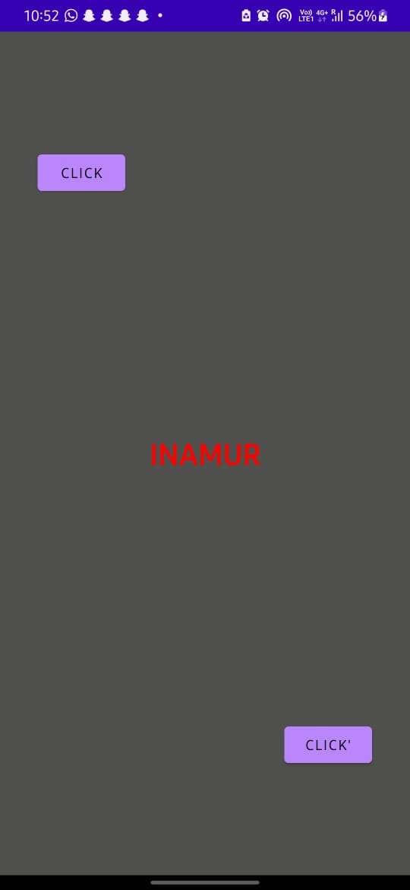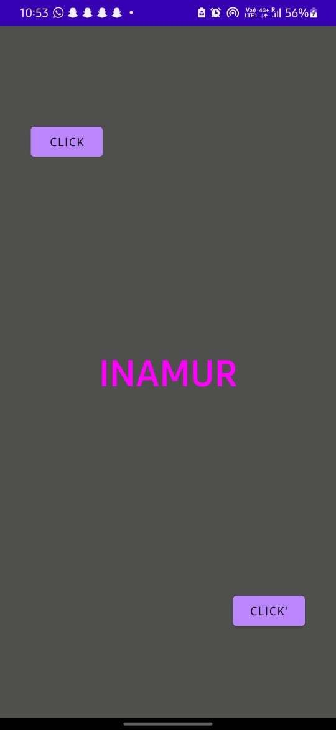

**RESULT:**

Hence simple application that uses GUI components was designed successfully.

Ex.no:03

**DEVELOP AN APPLICATION THAT USES LAYOUT MANAGERS AND EVENT LISTENERS**

Date :

**AIM:**

To develop an application that uses layout managers and event listeners.

**ALGORITHM:**

* Open Android studio and select new project
* Give Project name and select next
* Then type package name and the Application name as “LAYOUT MANAGERS″ and click Next.
* Go to package explorer in the lefthand side. Select our project.
* Then select the Minimum SDK as shown below and click Next.
* Then select the Empty Activity and click Next.
* Finally click Finish.
* Go to res folder and select layout. Double click the main.xml file.
* Now you can see the Graphics layout window
* Click the main.xml file and type the code below

**CODE:**

**Activity_main.xml:**

*<?*xml version="1.0" encoding="utf-8"*?>*

<androidx.constraintlayout.widget.ConstraintLayout

xmlns:android="<http://schemas.android.com/apk/res/android>"

xmlns:app="<http://schemas.android.com/apk/res-auto>" xmlns:tools="<http://schemas.android.com/tools>" android:layout_width="match_parent" android:layout_height="match_parent" android:background="#575252" tools:context=".MainActivity">

<LinearLayout

android:id="@+id/linearLayout" android:layout_width="410dp" android:layout_height="192dp" android:background="#BFC39C" android:gravity="center" android:orientation="horizontal" app:layout_constraintBottom_toBottomOf="parent" app:layout_constraintEnd_toEndOf="parent" app:layout_constraintHorizontal_bias="0.6" app:layout_constraintStart_toStartOf="parent" app:layout_constraintTop_toTopOf="parent" app:layout_constraintVertical_bias="0.0">

<ImageView

android:id="@+id/imageView3" android:layout_width="218dp" android:layout_height="wrap_content" android:layout_marginStart="16dp" android:layout_marginLeft="16dp" android:layout_marginTop="16dp" android:layout_weight="1" app:layout_constraintStart_toStartOf="parent" app:layout_constraintTop_toTopOf="parent" app:srcCompat="@drawable/istockphoto" />

<Button

android:id="@+id/button" android:layout_width="124dp" android:layout_height="52dp" android:layout_margin="20dp" android:layout_weight="1" android:paddingRight="10dp" android:text="Button" app:layout_constraintEnd_toEndOf="parent" app:layout_constraintStart_toStartOf="parent" />

</LinearLayout>

<TextView

android:id="@+id/textView" android:layout_width="308dp" android:layout_height="252dp" android:textAlignment="center" android:textColor="#8BBACF" android:textSize="20sp"

android:textStyle="bold" app:layout_constraintBottom_toBottomOf="parent" app:layout_constraintEnd_toEndOf="parent" app:layout_constraintStart_toStartOf="parent" app:layout_constraintTop_toBottomOf="@+id/linearLayout" app:layout_constraintVertical_bias="0.401" />

</androidx.constraintlayout.widget.ConstraintLayout>

**MainActivity.java:**

package com.example.myapplication;

import androidx.appcompat.app.AppCompatActivity;

import android.os.Bundle;

import android.view.View;

import android.widget.Button;

import android.widget.TextView;

public class MainActivity extends AppCompatActivity

{

Button b1;

TextView t1; @Override

protected void on Create (Bundle saved Instance State) { super.onCreate(savedInstanceState); setContentView(R.layout.activity_main);

b1 = findViewById(R.id.button);

t1 = findViewById(R.id.textView);

b1.setOnClickListener(new View.OnClickListener() {

@Override

public void onClick(View view) {

t1.setText("The Taj Mahal is an ivory-white marble mausoleum on the " +

"south bank of the Yamuna river in the Indian city of Agra. " +

"It was commissioned in 1632 by the Mughal emperor, Shah Jahan (reigned from 1628 to 1658), " + "to house the tomb of his favourite wife, Mumtaz Mahal.");}

});

}

}

**OUTPUT:**

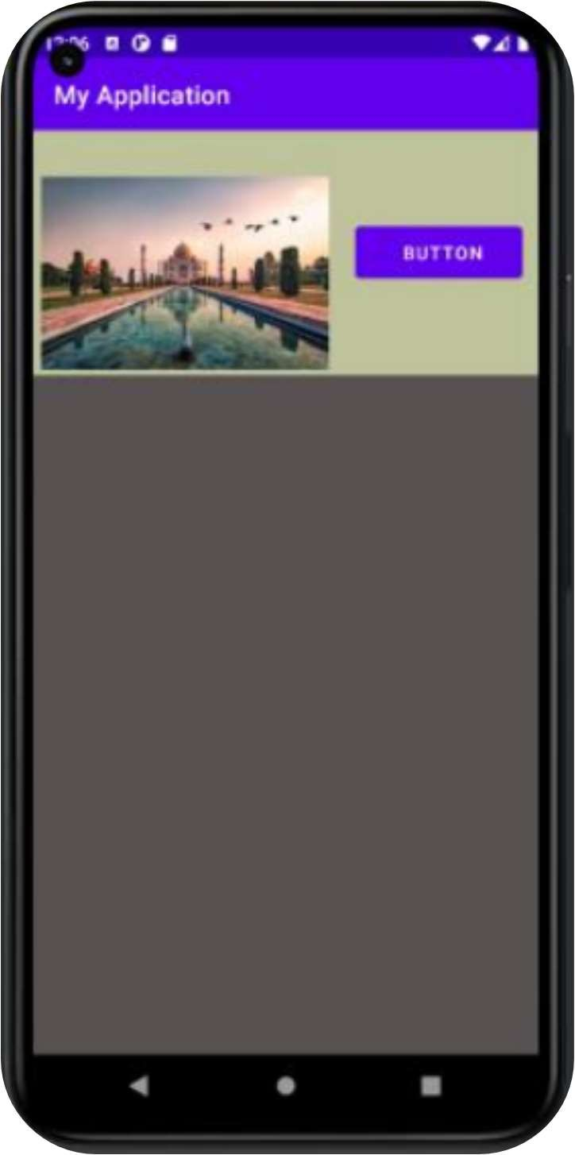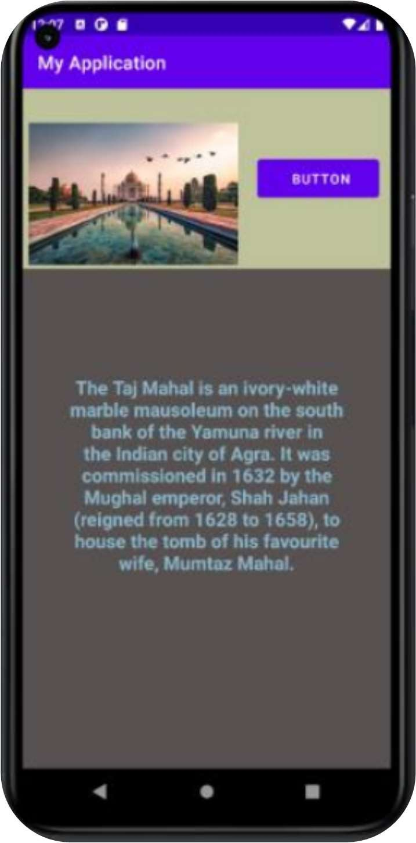

**RESULT:**

Thus, simple application that uses layout managers and event listeners was developed successfully.

Ex.no:04

**Develop a native calculator application**

Date :

**AIM:**

To develop a native calculator application.

**ALGORITHM:**

* Open Android studio and select new project
* Give Project name and select next
* Then type package name and the Application name as “CALCULATOR ″ and click Next.
* Go to package explorer in the lefthand side. Select our project.
* Then select the Minimum SDK as shown below and click Next.
* Then select the Empty Activity and click Next.
* Finally click Finish.
* Go to res folder and select layout. Double click the main.xml file.
* Now you can see the Graphics layout window
* Click the main.xml file and type the code below

**CODE:**

**Activity_main.xml:**

*<?*xml version="1.0" encoding="utf-8"*?>*

<RelativeLayout xmlns:android="<http://schemas.android.com/apk/res/android>" xmlns:app="<http://schemas.android.com/apk/res-auto>" xmlns:tools="<http://schemas.android.com/tools>" android:layout_width="match_parent" android:layout_height="match_parent"

tools:context=".MainActivity">

<TextView android:id="@+id/solutio”

android:layout_width="match_parent" android:layout_height="match_parent android:layout_above="@+id/result" android:layout_marginStart="0dp" android:layout_marginLeft="0dp" android:layout_marginTop="0dp" android:layout_marginEnd="0dp" android:layout_marginRight="0dp" android:layout_marginBottom="0dp" android:background="@color/black" android:gravity="end"

android:text="" android:textAlignment="textEnd" android:textColor="@color/white" android:textSize="100dp" />

<TextView android:id="@+id/result"

android:layout_width="match_parent" android:layout_height="wrap_content" android:layout_above="@+id/buttons_layout" android:layout_marginStart="0dp" android:layout_marginLeft="0dp" android:layout_marginTop="0dp" android:layout_marginEnd="0dp" android:layout_marginRight="0dp" android:layout_marginBottom="0dp" android:background="@color/black" android:gravity="end"

android:text="0" android:textAlignment="textEnd" android:textColor="@color/white" android:textSize="66dp" />

<LinearLayout android:layout_width="match_parent" android:layout_height="wrap_content" android:orientation="vertical" android:background="#000000"

android:layout_alignParentBottom="true" android:id="@+id/buttons_layout">

<LinearLayout android:layout_width="match_paren=android:layout_height="wrap_cone

android:gravity="center" android:orientation="horizontal">

<com.google.android.material.button.MaterialButton android:id="@+id/button_c" style="@style/Widget.MaterialComponents.ExtendedFloatingActionButton" android:layout_width="72dp"

android:layout_height="72dp" android:layout_margin="12dp" android:text="C" android:textColor="@color/white" android:textSize="32sp" app:backgroundTint="#FF0000" app:cornerRadius="36dp" />

<com.google.android.material.button.MaterialButton android:id="@+id/button_open" style="@style/Widget.MaterialComponents.ExtendedFloatingActionButton" android:layout_width="72dp"

android:layout_height="72dp" android:layout_margin="12dp" android:text="(" android:textColor="@color/white" android:textSize="32sp" app:backgroundTint="#787878" app:cornerRadius="36dp" />

<com.google.android.material.button.MaterialButton android:id="@+id/button_close" style="@style/Widget.MaterialComponents.ExtendedFloatingActionButton" android:layout_width="72dp"

android:layout_height="72dp" android:layout_margin="12dp" android:text=")" android:textColor="@color/white" android:textSize="32sp" app:backgroundTint="#787878" app:cornerRadius="36dp" />

<com.google.android.material.button.MaterialButton android:id="@+id/button_divide" style="@style/Widget.MaterialComponents.ExtendedFloatingActionButton" android:layout_width="72dp"

android:layout_height="72dp" android:layout_margin="12dp" android:backgroundTint="#FF9800" android:text="/" android:textColor="@color/whit

android:textSize="32sp" app:cornerRadius="36dp" />

</LinearLayout>

<LinearLayout android:layout_width="match_paren android:layout_height="wrap_conteandroid:orientation="horizontal" android:gravity="center">

<com.google.android.material.button.MaterialButton android:id="@+id/button_7" style="@style/Widget.MaterialComponents.ExtendedFloatingActionButton" android:layout_width="72dp"

android:layout_height="72dp" android:layout_margin="12dp" android:text="7" android:textColor="@color/white" android:textSize="32sp" app:cornerRadius="36dp" />

<com.google.android.material.button.MaterialButton android:id="@+id/button_8" style="@style/Widget.MaterialComponents.ExtendedFloatingActionButton" android:layout_width="72dp"

android:layout_height="72dp" android:layout_margin="12dp" android:text="8" android:textColor="@color/white" android:textSize="32sp" app:cornerRadius="36dp" />

<com.google.android.material.button.MaterialButton android:id="@+id/button_9" style="@style/Widget.MaterialComponents.ExtendedFloatingActionButton" android:layout_width="72dp"

android:layout_height="72dp" android:layout_margin="12dp" android:text="9" android:textColor="@color/white" android:textSize="32sp" app:cornerRadius="36dp" />

<com.google.android.material.button.MaterialButton android:id="@+id/button_multiply" style="@style/Widget.MaterialComponents.ExtendedFloatingActionButton" android:layout_width="72dp"

android:layout_height="72dp" android:layout_margin="12dp" android:backgroundTint="#FF9800" android:text="*" android:textColor="@color/white" android:textSize="32sp" app:cornerRadius="36dp" />

</LinearLayout>

<LinearLayout android:layout_width="match_parenandroid:layout_height="wrap_conte android:orientation="horizontal" android:gravity="center">

<com.google.android.material.button.MaterialButton android:id="@+id/button_4" style="@style/Widget.MaterialComponents.ExtendedFloatingActionButton" android:layout_width="72dp"

android:layout_height="72dp" android:layout_margin="12dp" android:text="4" android:textColor="@color/white" android:textSize="32sp" app:cornerRadius="36dp" />

<com.google.android.material.button.MaterialButton android:id="@+id/button_5" style="@style/Widget.MaterialComponents.ExtendedFloatingActionButton" android:layout_width="72dp"

android:layout_height="72dp" android:layout_margin="12dp" android:text="5" android:textColor="@color/white" android:textSize="32sp" app:cornerRadius="36dp" />

<com.google.android.material.button.MaterialButton android:id="@+id/button_6" style="@style/Widget.MaterialComponents.ExtendedFloatingActionButton" android:layout_width="72dp"

android:layout_height="72dp" android:layout_margin="12dp" android:text="6" android:textColor="@color/white" android:textSize="32sp" app:cornerRadius="36dp" />

<com.google.android.material.button.MaterialButton android:id="@+id/button_subtract" style="@style/Widget.MaterialComponents.ExtendedFloatingActionButton" android:layout_width="72dp"

android:layout_height="72dp" android:layout_margin="12dp" android:backgroundTint="#FF980

android:text="-" android:textColor="@color/white" android:textSize="32sp" app:cornerRadius="36dp" />

</LinearLayout>

<LinearLayout

android:layout_width="match_parenndroid:layout_height="wrap_contenandroid:orientation="horizontal" android:gravity="center">

<com.google.android.material.button.MaterialButton android:id="@+id/button_1" style="@style/Widget.MaterialComponents.ExtendedFloatingActionButton" android:layout_width="72dp"

android:layout_height="72dp" android:layout_margin="12dp" android:text="1" android:textColor="@color/white" android:textSize="32sp" app:cornerRadius="36dp" />

<com.google.android.material.button.MaterialButton android:id="@+id/button_2" style="@style/Widget.MaterialComponents.ExtendedFloatingActionButton" android:layout_width="72dp"

android:layout_height="72dp" android:layout_margin="12dp" android:text="2" android:textColor="@color/white" android:textSize="32sp" app:cornerRadius="36dp" />

<com.google.android.material.button.MaterialButton android:id="@+id/button_3" style="@style/Widget.MaterialComponents.ExtendedFloatingActionButton" android:layout_width="72dp"

android:layout_height="72dp" android:layout_margin="12dp" android:text="3" android:textColor="@color/white" android:textSize="32sp" app:cornerRadius="36dp" />

<com.google.android.material.button.MaterialButton android:id="@+id/button_add" style="@style/Widget.MaterialComponents.ExtendedFloatingActionButton" android:layout_width="72dp"

android:layout_height="72dp" android:layout_margin="12dp" android:backgroundTint="#FF9800" android:text="+" android:textColor="@color/white" android:textSize="32sp" app:cornerRadius="36dp" />

</LinearLayout>

<LinearLayout android:layout_width="match_paren

android:layout_height="wrap_content" android:gravity="center" android:orientation="horizontal">

<com.google.android.material.button.MaterialButton android:id="@+id/button_ac" style="@style/Widget.MaterialComponents.ExtendedFloatingActionButton" android:layout_width="72dp"

android:layout_height="72dp" android:layout_margin="12dp" android:text="AC" android:textColor="@color/white" android:textSize="21sp" app:backgroundTint="#FF0000" app:cornerRadius="36dp" />

<com.google.android.material.button.MaterialButton android:id="@+id/button_0" style="@style/Widget.MaterialComponents.ExtendedFloatingActionButton" android:layout_width="72dp"

android:layout_height="72dp" android:layout_margin="12dp" android:text="0" android:textColor="@color/white" android:textSize="32sp" app:cornerRadius="36dp" />

<com.google.android.material.button.MaterialButton android:id="@+id/button_dot" style="@style/Widget.MaterialComponents.ExtendedFloatingActionButton" android:layout_width="72dp"

android:layout_height="72dp" android:layout_margin="12dp" android:text="." android:textColor="@color/white" android:textSize="32sp" app:backgroundTint="#6E6C6C" app:cornerRadius="36dp" />

<com.google.android.material.button.MaterialButton android:id="@+id/button_equals" style="@style/Widget.MaterialComponents.ExtendedFloatingActionButton" android:layout_width="72dp"

android:layout_height="72dp" android:layout_margin="12dp" android:backgroundTint="#FF9800" android:text="=" android:textColor="@color/whitandroid:textSize="32sp" app:cornerRadius="36dp" />

</LinearLayout>

</LinearLayout>

</RelativeLayou

**MainActivity.java:**

package com.example.calculator;

import androidx.appcompat.app.AppCompatActivity; import android.os.Bundle;

import android.view.View; importndroid.widget.TextView;

importcom.google.android.material.button.MaterialButto import org.mozilla.javascript.Context;

import org.mozilla.javascript.Scriptable;

public class MainActivity extends AppCompatActivity implements View.OnClickListener { TextView result,solution;

MaterialButton buttonc,buttonopen,buttonclose;

MaterialButton buttondivide, buttonmultiply, buttonadd, buttonsubtract, buttonequals; MaterialButton button0, button1, button2, button3, button4, button5, button6,

button7,button8, button9; MaterialButton buttonac, uttondot; @Override

protected void onCreate(Bundle saved Instance State) { super.onCreate(savedInstanceState); setContentView(R.layout.*activity_main*);

result = findViewById(R.id.*result*); solution = indViewById(R.id.*solution*); assignId(buttonc,R.id.*button_c*); assignId(buttonopen,R.id.*button_ope* assignId(buttonclose,R.id.*button_clos*assignId(buttondivide,R.id.*button_divid*assignId(buttonmultiply,R.id.*button_mu*assignId(buttonadd,R.id.*button_add*); assignId(buttonsubtract,R.id.*button_subtract*); assignId(buttonequals,R.id.*button_equals*); assignId(buttonac,R.id.*button_ac*); assignId(button0,R.id.*button_0*); assignId(button1,R.id.*button_1*); assignId(button2,R.id.*button_2*); assignId(button3,R.id.*button_3*); assignId(button4,R.id.*button_4*); assignId(button5,R.id.*button_5*); assignId(button6,R.id.*button_6*); assignId(button7,R.id.*button_7*); assignId(button8,R.id.*button_8*); assignId(button9,R.id.*button_9*); assignId(buttondot,R.id.*button_dot*); }

void assignId(MaterialButton btn, int id){ btn = findViewById(id); btn.setOnClickListener(this); }

@Override

public void onClick(View view) {

MaterialButton button = (MaterialButton) view;

String buttonText = button.getText().toString(); String dataToCalculate = solution.getText().toString(); if (buttonText.equals("AC")){

solution.setText("; result.setText("0) return; }

if (buttonText.equals("=")){ solution.setText(result.getText()); return; }

if (buttonText.equals("C")){

dataToCalculate = dataToCalculate.substring(0,dataToCalculate.length()-1); } else{

dataToCalculate = dataToCalculate + buttonText; } solution.setText(dataToCalculate);

String finalResult = getResult(dataToCalculate); if(!finalResult.equals("Err")){

result.setText(finalResult);

}

}

String getResult(String data) { try {

Context context =ntext.*enter*(); context.setOptimizationLevel(-

Scriptable scriptable = context.initStandardObjects();

String finalResult = context.evaluateString(scriptable, data, "Javascript", 1, null).toString(); if (finalResult.endsWith(".0")) {

finalResult = finalResult.replace(".0", "");

}

return finalResult;

} catch(Exceptioe) { return "Err";

}

}

}

OUTPUT:

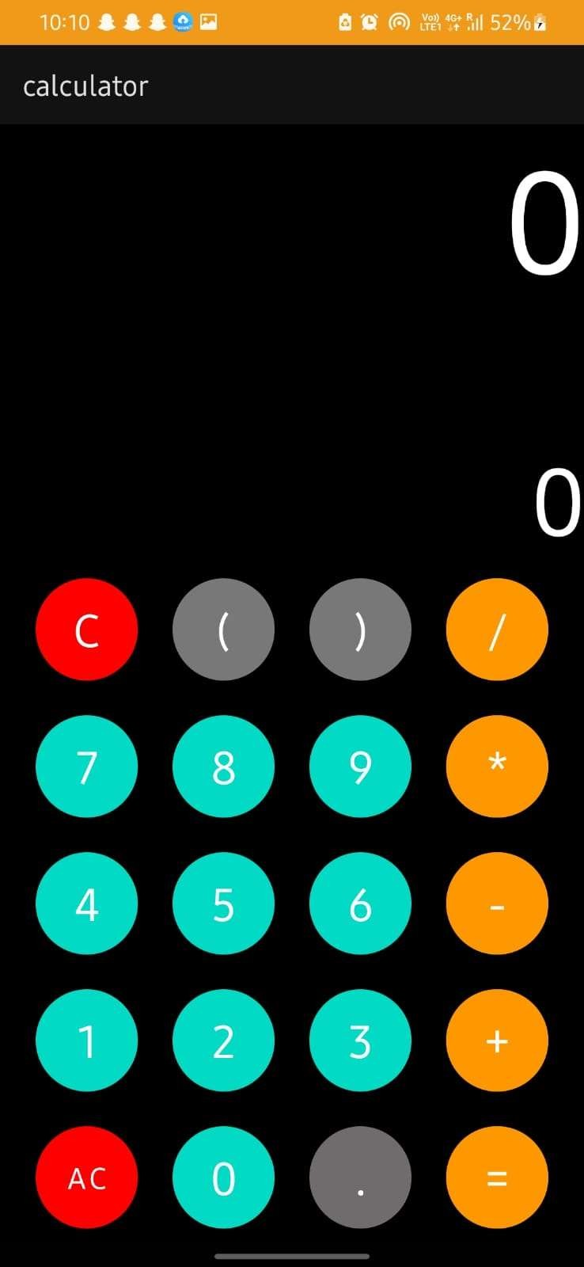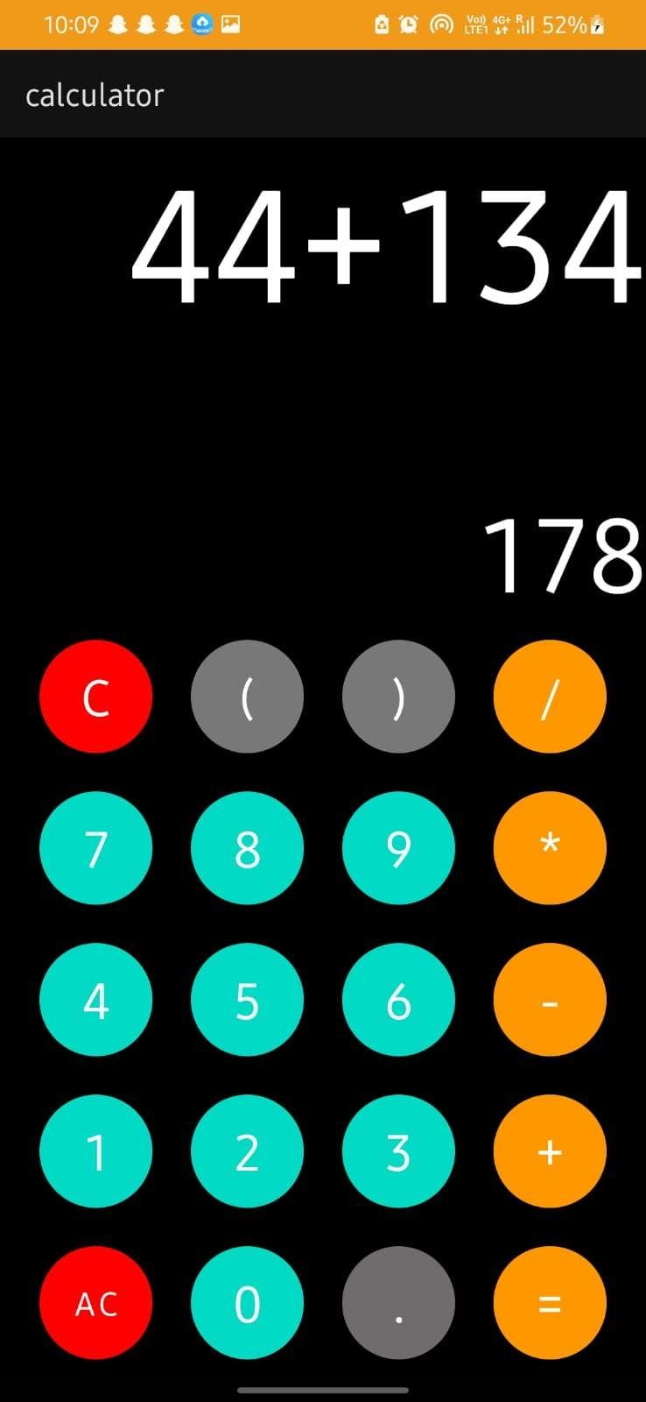

**RESULT:**

Thus a native calculator application was developed successfully.

Ex.no:05

**WRITE AN APPLICATION THAT DRAWS BASIC GRAPHICAL PRIMITIVES ON THE SCREEN IN ANDROID**

Date :

**AIM:**

To develop a application that draws basic graphical primitives on the screen in android

**ALGORITHM**

* Open Android studio and select new project
* Give Project name and select next
* Then type package name and the Application name as “GRAPHICS″ and click Next.
* Go to package explorer in the lefthand side. Select our project.
* Then select the Minimum SDK as shown below and click Next.
* Then select the Empty Activity and click Next.
* Finally click Finish.
* Go to res folder and select layout. Double click the main.xml file.
* Now you can see the Graphics layout window
* Click the main.xml file and type the code below

**CODE:**

**Activity_main.xml:**

<?xml version="1.0" encoding="utf-8"?>

<RelativeLayout xmlns:android="http://schemas.android.com/apk/res/android"

android:layout_width="match_parent"

android:layout_height="match_parent">

<ImageView

android:layout_width="match_parent"

android:layout_height="match_parent"

android:id="@+id/imageView" />

</RelativeLayout>

**MainActivity.java:**

package com.example.shapes;

import android.app.Activity;

import android.graphics.Bitmap;

import android.graphics.Canvas;

import android.graphics.Color;

import android.graphics.Paint;

import android.graphics.drawable.BitmapDrawable;

import android.os.Bundle;

import android.widget.ImageView;

public class MainActivity extends Activity {

@Override

public void onCreate(Bundle savedInstanceState) {

super.onCreate(savedInstanceState);

setContentView(R.layout.activity_main);

Bitmap bg = Bitmap.createBitmap(720, 1280, Bitmap.Config.ARGB_8888);

ImageView i = (ImageView) findViewById(R.id.imageView);

i.setBackgroundDrawable(new BitmapDrawable(bg));

Canvas canvas = new Canvas(bg);

Paint paint = new Paint();

paint.setColor(Color.RED);

paint.setTextSize(50);

canvas.drawText("Rectangle", 420, 150, paint);

canvas.drawRect(400, 200, 650, 700, paint);

canvas.drawText("Circle", 120, 150, paint);

canvas.drawCircle(200, 350, 150, paint);

canvas.drawText("Square", 120, 800, paint);

canvas.drawRect(50, 850, 350, 1150, paint);

canvas.drawText("Line", 480, 800, paint);

canvas.drawLine(520, 850, 520, 1150, paint);

} }

**OUTPUT:**

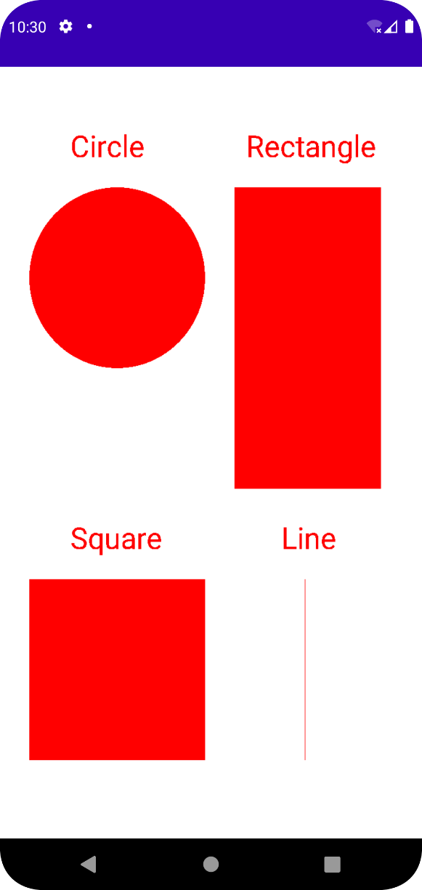

**RESULT:**

Thus an application that draws basic graphical primitives on the screen in android was developed Successfully.

Ex.no:06

**Develop an application that make use of database**

Date :

**AIM:**

To develop an application that make use of database.

**ALGORITHM**

* Open Android studio and select new project
* Give Project name and select next
* Then type package name and the Application name as “DATABASE″ and click Next.
* Go to package explorer in the lefthand side. Select our project.
* Then select the Minimum SDK as shown below and click Next.
* Then select the Empty Activity and click Next.
* Finally click Finish.
* Go to res folder and select layout. Double click the main.xml file.
* Now you can see the Graphics layout window
* Click the main.xml file and type the code below

**CODE:**

**Activity_main.xml:**

<?xml version="1.0" encoding="utf-8"?>

<AbsoluteLayout xmlns:android="http://schemas.android.com/apk/res/android"

    android:layout_width="match_parent"

    android:layout_height="match_parent">

    <TextView

        android:layout_width="wrap_content"

        android:layout_height="wrap_content"

        android:layout_x="50dp"

        android:layout_y="20dp"

        android:text="Student Details"

        android:textSize="30sp" />

    <TextView

        android:layout_width="wrap_content"

        android:layout_height="wrap_content"

        android:layout_x="20dp"

        android:layout_y="110dp"

        android:text="Enter Rollno:"

        android:textSize="20sp" />

    <EditText

        android:id="@+id/Rollno"

        android:layout_width="150dp"

        android:layout_height="wrap_content"

        android:layout_x="175dp"

        android:layout_y="100dp"

        android:inputType="number"

        android:textSize="20sp" />

    <TextView

        android:layout_width="wrap_content"

        android:layout_height="wrap_content"

        android:layout_x="20dp"

        android:layout_y="160dp"

        android:text="Enter Name:"

        android:textSize="20sp" />

    <EditText

        android:id="@+id/Name"

        android:layout_width="150dp"

        android:layout_height="wrap_content"

        android:layout_x="175dp"

        android:layout_y="150dp"

        android:inputType="text"

        android:textSize="20sp" />

    <TextView

        android:layout_width="wrap_content"

        android:layout_height="wrap_content"

        android:layout_x="20dp"

        android:layout_y="210dp"

        android:text="Enter Marks:"

        android:textSize="20sp" />

    <EditText

        android:id="@+id/Marks"

        android:layout_width="150dp"

        android:layout_height="wrap_content"

        android:layout_x="175dp"

        android:layout_y="200dp"

        android:inputType="number"

        android:textSize="20sp" />

    <Button

        android:id="@+id/Insert"

        android:layout_width="150dp"

        android:layout_height="wrap_content"

        android:layout_x="25dp"

        android:layout_y="300dp"

        android:text="Insert"

        android:textSize="30dp" />

    <Button

        android:id="@+id/Delete"

        android:layout_width="150dp"

        android:layout_height="wrap_content"

        android:layout_x="200dp"

        android:layout_y="300dp"

        android:text="Delete"

        android:textSize="30dp" />

    <Button

        android:id="@+id/Update"

        android:layout_width="150dp"

        android:layout_height="wrap_content"

        android:layout_x="25dp"

        android:layout_y="400dp"

        android:text="Update"

        android:textSize="30dp" />

    <Button

        android:id="@+id/View"

        android:layout_width="150dp"

        android:layout_height="wrap_content"

        android:layout_x="200dp"

        android:layout_y="400dp"

        android:text="View"

        android:textSize="30dp" />

    <Button

        android:id="@+id/ViewAll"

        android:layout_width="200dp"

        android:layout_height="wrap_content"

        android:layout_x="100dp"

        android:layout_y="500dp"

        android:text="View All"

        android:textSize="30dp" />

</AbsoluteLayout>

**MainActivity.java:**

package com.example.database;

package com.example.exno5;

import android.app.Activity;

import android.app.AlertDialog.Builder;

import android.content.Context;

import android.database.Cursor;

import android.database.sqlite.SQLiteDatabase;

import android.os.Bundle;

import android.view.View;

import android.view.View.OnClickListener;

import android.widget.Button;

import android.widget.EditText;

public class MainActivity extends Activity implements OnClickListener

{

    EditText Rollno,Name,Marks;

    Button Insert,Delete,Update,View,ViewAll;

    SQLiteDatabase db;

    @Override

    public void onCreate(Bundle savedInstanceState)

    {

        super.onCreate(savedInstanceState);

        setContentView(R.layout.activity_main);

        Rollno=(EditText)findViewById(R.id.Rollno);

        Name=(EditText)findViewById(R.id.Name);

        Marks=(EditText)findViewById(R.id.Marks);

        Insert=(Button)findViewById(R.id.Insert);

        Delete=(Button)findViewById(R.id.Delete);

        Update=(Button)findViewById(R.id.Update);

        View=(Button)findViewById(R.id.View);

        ViewAll=(Button)findViewById(R.id.ViewAll);

        Insert.setOnClickListener(this);

        Delete.setOnClickListener(this);

        Update.setOnClickListener(this);

        View.setOnClickListener(this);

        ViewAll.setOnClickListener(this);

         db=openOrCreateDatabase("StudentDB", Context.MODE_PRIVATE, null);

        db.execSQL("CREATE TABLE IF NOT EXISTS student(rollno VARCHAR,name VARCHAR,marks VARCHAR);");    }

    public void onClick(View view)

    {        if(view==Insert)

        {

 if(Rollno.getText().toString().trim().length()==0||

                    Name.getText().toString().trim().length()==0||

                    Marks.getText().toString().trim().length()==0)            {

                showMessage("Error", "Please enter all values");

                return;            }

            db.execSQL("INSERT INTO student VALUES('"+Rollno.getText()+"','"+Name.getText()+

                    "','"+Marks.getText()+"');");

            showMessage("Success", "Record added");

            clearText();        }

        if(view==Delete)        {

            if(Rollno.getText().toString().trim().length()==0)            {

                showMessage("Error", "Please enter Rollno");

                return;            }

            Cursor c=db.rawQuery("SELECT * FROM student WHERE rollno='"+Rollno.getText()+"'", null);

            if(c.moveToFirst())            {

                db.execSQL("DELETE FROM student WHERE rollno='"+Rollno.getText()+"'");

                showMessage("Success", "Record Deleted");            }

            else            {

                showMessage("Error", "Invalid Rollno");            }

            clearText();        }

        if(view==Update)        {

            if(Rollno.getText().toString().trim().length()==0)            {

                showMessage("Error", "Please enter Rollno");

                return;            }

            Cursor c=db.rawQuery("SELECT * FROM student WHERE rollno='"+Rollno.getText()+"'", null);

            if(c.moveToFirst()) {

                db.execSQL("UPDATE student SET name='" + Name.getText() + "',marks='" + Marks.getText() +

                        "' WHERE rollno='"+Rollno.getText()+"'");

                showMessage("Success", "Record Modified");            }

            else {

                showMessage("Error", "Invalid Rollno");            }

            clearText();        }

        if(view==View)        {

            if(Rollno.getText().toString().trim().length()==0)            {

                showMessage("Error", "Please enter Rollno");

                return;            }

            Cursor c=db.rawQuery("SELECT * FROM student WHERE rollno='"+Rollno.getText()+"'", null);

            if(c.moveToFirst())            {

                Name.setText(c.getString(1));

                Marks.setText(c.getString(2));            }

            else            {

                showMessage("Error", "Invalid Rollno");

                clearText();            }        }

        if(view==ViewAll)

        {

            Cursor c=db.rawQuery("SELECT * FROM student", null);

            if(c.getCount()==0)            {

                showMessage("Error", "No records found");

                return;            }

            StringBuffer buffer=new StringBuffer();

            while(c.moveToNext())

            {

                buffer.append("Rollno: "+c.getString(0)+"\n");

                buffer.append("Name: "+c.getString(1)+"\n");

                buffer.append("Marks: "+c.getString(2)+"\n\n");            }

            showMessage("Student Details", buffer.toString());

        }    }

    public void showMessage(String title,String message)

    {

        Builder builder=new Builder(this);

        builder.setCancelable(true);

        builder.setTitle(title);

        builder.setMessage(message);

        builder.show();    }

    public void clearText()

    {

        Rollno.setText("");

        Name.setText("");

        Marks.setText("");

     Rollno.requestFocus();    } }

**OUTPUT:**

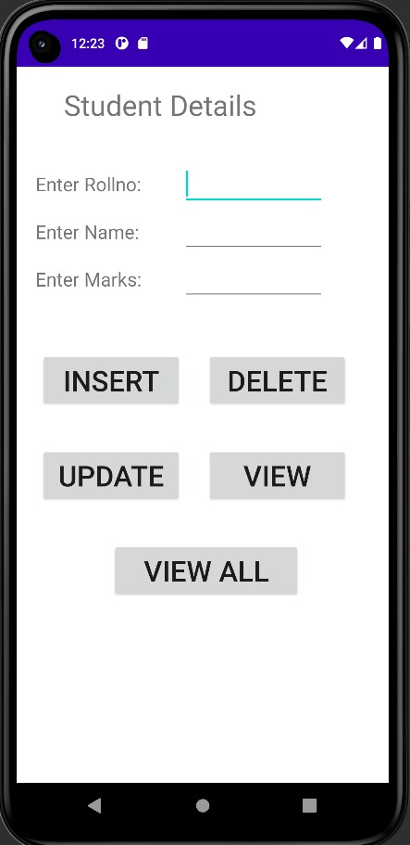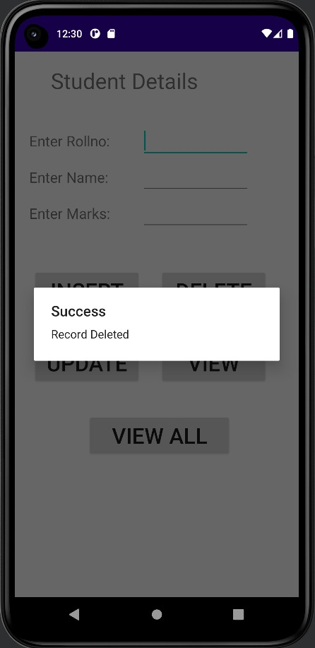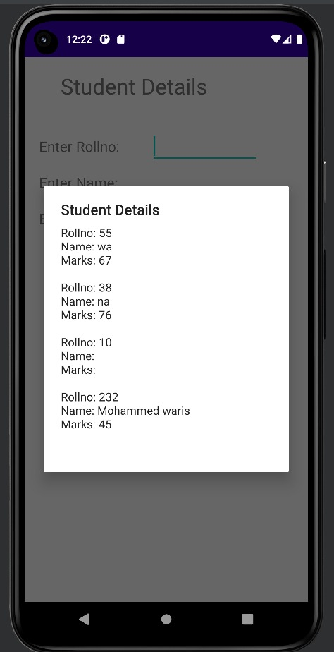

**RESULT:**

Thus a Simple Android Application that makes use of Database is developed andexecuted Successfully.

Ex.no:07

**Develop an application that makes use of RSS Feed**

Date :

**AIM:**

To develop a Simple Android Application that makes use of RSS Feed.

**ALGORITHM**

* Open Android studio and select new project
* Give Project name and select next
* Then type package name and the Application name as “RSS FEED″ and click Next.
* Go to package explorer in the lefthand side. Select our project.
* Then select the Minimum SDK as shown below and click Next.
* Then select the Empty Activity and click Next.
* Finally click Finish.
* Go to res folder and select layout. Double click the main.xml file.
* Now you can see the Graphics layout window
* Click the main.xml file and type the code below

**CODE:**

**Activity_main.xml**

<?xml version="1.0" encoding="utf-8"?>

<LinearLayout xmlns:android="http://schemas.android.com/apk/res/android"

android:layout_width="fill_parent"

android:layout_height="fill_parent"

android:orientation="vertical" >

<ListView

android:id="@+id/listView"

android:layout_width="match_parent"

android:layout_height="wrap_content" />

</LinearLayout>

### ****AndroidManifest.xml:****

<?xml version="1.0" encoding="utf-8"?>

<manifest xmlns:android="http://schemas.android.com/apk/res/android"

package="com.example.exno6" >

<uses-permission android:name="android.permission.INTERNET"/>

<application

android:allowBackup="true"

android:icon="@mipmap/ic_launcher"

android:label="@string/app_name"

android:supportsRtl="true"

android:theme="@style/AppTheme" >

<activity android:name=".MainActivity" >

<intent-filter>

<action android:name="android.intent.action.MAIN" />

<category android:name="android.intent.category.LAUNCHER" />

</intent-filter>

</activity>

</application>

</manifest>

**Code for MainActivity.java:**

package com.example.rssfeed;

import android.app.ListActivity;

import android.content.Intent;

import android.net.Uri;

import android.os.AsyncTask;

import android.os.Bundle;

import android.view.View;

import android.widget.ArrayAdapter;

import android.widget.ListView;

import org.xmlpull.v1.XmlPullParser;

import org.xmlpull.v1.XmlPullParserException;

import org.xmlpull.v1.XmlPullParserFactory;

import java.io.IOException;

import java.io.InputStream;

import java.net.MalformedURLException;

import java.net.URL;

import java.util.ArrayList;

import java.util.List;

public class MainActivity extends ListActivity

{

List headlines;

List links;

@Override

protected void onCreate(Bundle savedInstanceState)

{

super.onCreate(savedInstanceState);

new MyAsyncTask().execute(); }

class MyAsyncTask extends AsyncTask<Object,Void,ArrayAdapter>

{

@Override

protected ArrayAdapter doInBackground(Object[] params)

{

headlines = new ArrayList();

links = new ArrayList();

try {

URL url = new URL("https://codingconnect.net/feed");

XmlPullParserFactory factory = XmlPullParserFactory.newInstance();

factory.setNamespaceAware(false);

XmlPullParser xpp = factory.newPullParser();

xpp.setInput(getInputStream(url), "UTF_8");

boolean insideItem = false;

int eventType = xpp.getEventType();

while (eventType != XmlPullParser.END_DOCUMENT)

{

if (eventType == XmlPullParser.START_TAG)

{

if (xpp.getName().equalsIgnoreCase("item"))

{

insideItem = true; }

else if (xpp.getName().equalsIgnoreCase("title"))

{

if (insideItem)

headlines.add(xpp.nextText()); }

else if (xpp.getName().equalsIgnoreCase("link"))

{

if (insideItem)

links.add(xpp.nextText()); } }

else if(eventType==XmlPullParser.END_TAG && xpp.getName().equalsIgnoreCase("item"))

{

insideItem=false; }

eventType = xpp.next(); } }

catch (MalformedURLException e)

{

e.printStackTrace(); }

catch (XmlPullParserException e) {

e.printStackTrace(); }

catch (IOException e)

{

e.printStackTrace(); }

return null; }

protected void onPostExecute(ArrayAdapter adapter)

{

adapter = new ArrayAdapter(MainActivity.this, android.R.layout.simple_list_item_1, headlines);

setListAdapter(adapter);

} }

@Override

protected void onListItemClick(ListView l, View v, int position, long id)

{

Uri uri = Uri.parse((links.get(position)).toString());

Intent intent = new Intent(Intent.ACTION_VIEW, uri);

startActivity(intent); }

public InputStream getInputStream(URL url)

{

try

{

return url.openConnection().getInputStream(); }

catch (IOException e)

{

return null;

} } }

**OUTPUT:**

**RESULT:**

Thus Android Application that makes use of RSS Feed is developed and executed successfully.

Ex.no:08

**Implement an application that Implements**

**Multi threading**

Date :

**AIM:**

To implement an application that implements Multi threading.

**ALGORITHM**

* Open Android studio and select new project
* Give Project name and select next
* Then type package name and the Application name as “MULTITHREADING″ and click Next.
* Go to package explorer in the lefthand side. Select our project.
* Then select the Minimum SDK as shown below and click Next.
* Then select the Empty Activity and click Next.
* Finally click Finish.
* Go to res folder and select layout. Double click the main.xml file.
* Now you can see the Graphics layout window
* Click the main.xml file and type the code below

**CODE:**

**Activity_main.xml**

<?xml version="1.0" encoding="utf-8"?>

<LinearLayout xmlns:android="http://schemas.android.com/apk/res/android"

android:layout_width="match_parent"

android:layout_height="match_parent"

android:orientation="vertical" >

<ImageView

android:id="@+id/imageView"

android:layout_width="250dp"

android:layout_height="250dp"

android:layout_margin="50dp"

android:layout_gravity="center" />

<Button

android:id="@+id/button"

android:layout_width="wrap_content"

android:layout_height="wrap_content"

android:layout_margin="10dp"

android:layout_gravity="center"

android:text="Load Image 1" />

<Button

android:id="@+id/button2"

android:layout_width="wrap_content"

android:layout_height="wrap_content"

android:layout_margin="10dp"

android:layout_gravity="center"

android:text="Load image 2" />

</LinearLayout>

**MainActivity.java:**

package com.example.multithreading;

import android.os.Bundle;

import androidx.appcompat.app.AppCompatActivity;

import android.view.View;

import android.widget.Button;

import android.widget.ImageView;

public class MainActivity extends AppCompatActivity

{

ImageView img;

Button bt1,bt2;

@Override

protected void onCreate(Bundle savedInstanceState)

{

super.onCreate(savedInstanceState);

setContentView(R.layout.activity_main);

bt1 = (Button)findViewById(R.id.button);

bt2= (Button) findViewById(R.id.button2);

img = (ImageView)findViewById(R.id.imageView);

bt1.setOnClickListener(new View.OnClickListener()

{

@Override

public void onClick(View v)

{

new Thread(new Runnable()

{

@Override

public void run()

{

img.post(new Runnable()

{

@Override

public void run()

{

img.setImageResource(R.drawable.india1);

} }); }

}).start();

} });

bt2.setOnClickListener(new View.OnClickListener()

{

@Override

public void onClick(View v)

{

new Thread(new Runnable()

{

@Override

public void run()

{

img.post(new Runnable()

{

@Override

public void run()

{

img.setImageResource(R.drawable.india2);

} }); }

}).start();

}

});

} }

**OUTPUT :**

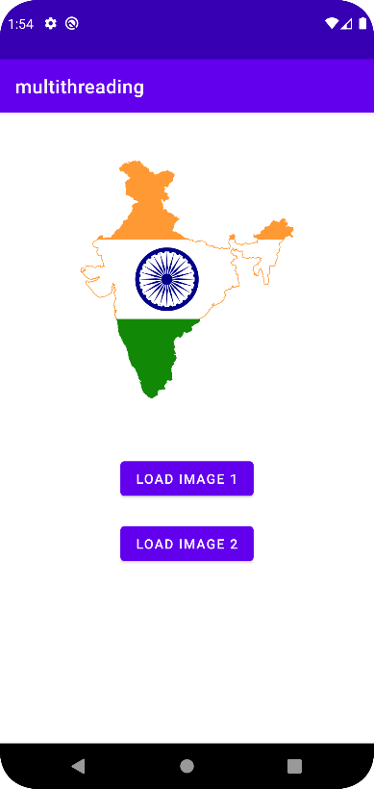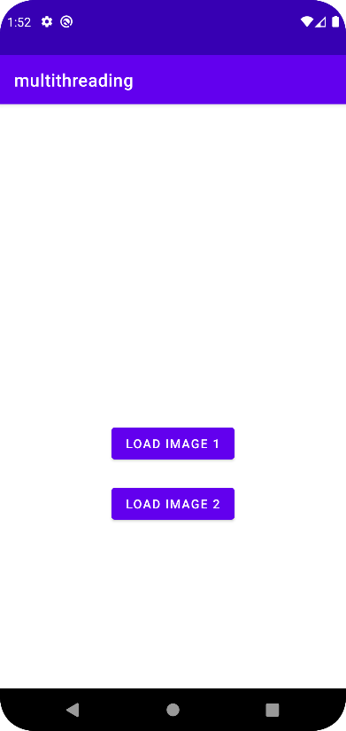

**RESULT:**

Thus, Android Application that implements Multi-threading is developed and executed Successfully.

Ex.no:09

**Develop a native application that uses GPS location Information**

Date :

**AIM:**

To develop a native application that uses GPS location Information.

**ALGORITHM**

* Open Android studio and select new project
* Give Project name and select next
* Then type package name and the Application name as “gps″ and click Next.
* Go to package explorer in the lefthand side. Select our project.
* Then select the Minimum SDK as shown below and click Next.
* Then select the Empty Activity and click Next.
* Finally click Finish.
* Go to res folder and select layout. Double click the main.xml file.
* Now you can see the Graphics layout window
* Click the main.xml file and type the code below

**CODE:**

**Activity_main.xml**

<?xml version="1.0" encoding="utf-8"?>

<LinearLayout xmlns:android="http://schemas.android.com/apk/res/android"

android:layout_marginTop="300dp"

android:layout_marginLeft="100dp"

android:orientation="vertical"

android:layout_width="fill_parent"

android:layout_height="fill_parent" >

<Button

android:id="@+id/retrieve_location_button"

android:layout_width="wrap_content"

android:layout_height="wrap_content"

android:text="Retrieve Location" />

</LinearLayout>

**AndroidManifest.xml**

<?xml version="1.0" encoding="utf-8"?>

<manifest xmlns:android="http://schemas.android.com/apk/res/android"

xmlns:tools="http://schemas.android.com/tools">

<application

android:allowBackup="true"

android:dataExtractionRules="@xml/data_extraction_rules"

android:fullBackupContent="@xml/backup_rules"

android:icon="@mipmap/ic_launcher"

android:label="@string/app_name"

android:supportsRtl="true"

android:theme="@style/Theme.Gps"

tools:targetApi="31">

<activity

android:name=".MainActivity"

android:exported="true">

<intent-filter>

<action android:name="android.intent.action.MAIN" />

<category android:name="android.intent.category.LAUNCHER" />

</intent-filter>

</activity>

</application>

<uses-permission android:name="android.permission.ACCESS_COARSE_LOCATION"/>

<uses-permission android:name="android.permission.ACCESS_FINE_LOCATION"/>

</manifest>

**MainActivity.java:**

package com.example.gps;

import androidx.core.app.ActivityCompat;

import android.content.pm.PackageManager;

import android.os.Bundle;

import android.app.Activity;

import android.content.Context;

import android.location.Location;

import android.location.LocationListener;

import android.location.LocationManager;

import android.view.View;

import android.view.View.OnClickListener;

import android.widget.Button;

import android.widget.Toast;

public class MainActivity extends Activity {

private static final long MINIMUM_DISTANCE_CHANGE_FOR_UPDATES = 1; // in Meters

private static final long MINIMUM_TIME_BETWEEN_UPDATES = 1000; // in Milliseconds

protected LocationManager locationManager;

protected Button retrieveLocationButton;

@Override

public void onCreate(Bundle savedInstanceState) {

super.onCreate(savedInstanceState);

setContentView(R.layout.activity_main);

retrieveLocationButton = (Button) findViewById(R.id.retrieve_location_button);

locationManager = (LocationManager) getSystemService(Context.LOCATION_SERVICE);

if (ActivityCompat.checkSelfPermission(this, android.Manifest.permission.ACCESS_FINE_LOCATION) != PackageManager.PERMISSION_GRANTED && ActivityCompat.checkSelfPermission(this,ndroid.Manifest.permission.ACCESS_COARSE_LOCATION) != PackageManager.PERMISSION_GRANTED) {

return;

}

locationManager.requestLocationUpdates(LocationManager.GPS_PROVIDER, MINIMUM_TIME_BETWEEN_UPDATES, MINIMUM_DISTANCE_CHANGE_FOR_UPDATES, new MyLocationListener()

);

retrieveLocationButton.setOnClickListener(new OnClickListener() {

@Override

public void onClick(View v) {

showCurrentLocation(); }

});

}

protected void showCurrentLocation() {

if (ActivityCompat.checkSelfPermission(this, android.Manifest.permission.ACCESS_FINE_LOCATION) != PackageManager.PERMISSION_GRANTED && ActivityCompat.checkSelfPermission(this, android.Manifest.permission.ACCESS_COARSE_LOCATION) != PackageManager.PERMISSION_GRANTED) {

return;

}

Location location = locationManager.getLastKnownLocation(LocationManager.GPS_PROVIDER);

if (location != null) {

String message = String.format(

"Current Location \n Longitude: %1$s \n Latitude: %2$s",

location.getLongitude(), location.getLatitude()

);

Toast.makeText(MainActivity.this, message,

Toast.LENGTH_LONG).show();

}

}

private class MyLocationListener implements LocationListener {

public void onLocationChanged(Location location) {

String message = String.format(

"New Location \n Longitude: %1$s \n Latitude: %2$s",

location.getLongitude(), location.getLatitude()

);

Toast.makeText(MainActivity.this, message, Toast.LENGTH_LONG).show();

}

public void onStatusChanged(String s, int i, Bundle b) {

Toast.makeText(MainActivity.this, "Provider status changed",

Toast.LENGTH_LONG).show();

}

public void onProviderDisabled(String s) {

Toast.makeText(MainActivity.this,

"Provider disabled by the user. GPS turned off",

Toast.LENGTH_LONG).show(); }

public void onProviderEnabled(String s) {

Toast.makeText(MainActivity.this,

"Provider enabled by the user. GPS turned on",

Toast.LENGTH_LONG).show();

}}}

**OUTPUT:**

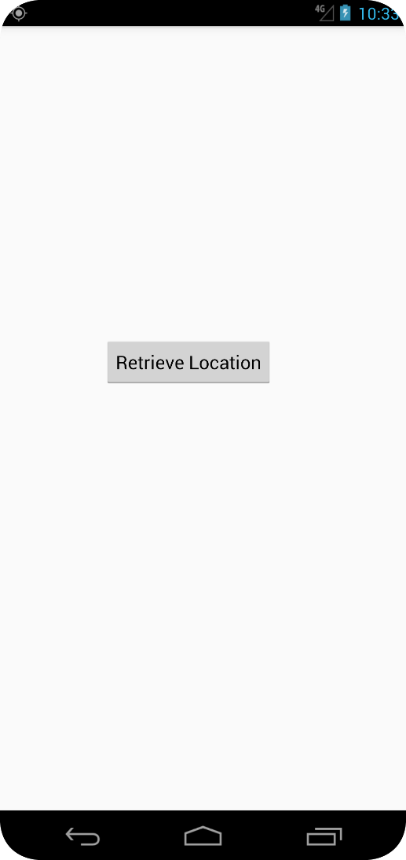

**RESULT:**

Thus Android Application that makes use of Location was developed and implemented successfully.

Ex.no:10

**Implement an application that creates an alert upon receiving a message**

Date :

**AIM:**

To implement an application that creates an alert upon receiving a message.

**ALGORITHM**

* Open Android studio and select new project
* Give Project name and select next
* Then type package name and the Application name as “ALERT″ and click Next.
* Go to package explorer in the lefthand side. Select our project.
* Then select the Minimum SDK as shown below and click Next.
* Then select the Empty Activity and click Next.
* Finally click Finish.
* Go to res folder and select layout. Double click the main.xml file.
* Now you can see the Graphics layout window
* Click the main.xml file and type the code below

**CODE:**

**Activity_main.xml:**

<?xml version="1.0" encoding="utf-8"?>

<androidx.constraintlayout.widget.ConstraintLayout xmlns:android="http://schemas.android.com/apk/res/android"

xmlns:app="http://schemas.android.com/apk/res-auto"

xmlns:tools="http://schemas.android.com/tools"

android:layout_width="match_parent"

android:layout_height="match_parent"

tools:context=".MainActivity">

<TextView

android:id="@+id/textView3"

android:layout_width="wrap_content"

android:layout_height="wrap_content"

android:text="ANDROID NOTIFICATION"

android:textAppearance="@style/Base.TextAppearance.AppCompat.Medium"

app:layout_constraintBottom_toBottomOf="parent"

app:layout_constraintLeft_toLeftOf="parent"

app:layout_constraintRight_toRightOf="parent"

app:layout_constraintTop_toTopOf="parent"

app:layout_constraintVertical_bias="0.091" />

<Button

android:layout_width="wrap_content"

android:layout_height="wrap_content"

android:id="@+id/button"

android:layout_marginBottom="112dp"

android:layout_marginEnd="8dp"

android:layout_marginStart="8dp"

android:text="Notify"

app:layout_constraintBottom_toBottomOf="parent"

app:layout_constraintEnd_toEndOf="parent"

app:layout_constraintStart_toStartOf="parent" />

<TextView

android:id="@+id/textView"

android:layout_width="wrap_content"

android:layout_height="wrap_content"

android:text="Press the below button "

android:textSize="30dp"

app:layout_constraintBottom_toTopOf="@+id/button"

app:layout_constraintTop_toBottomOf="@+id/textView3"

tools:layout_editor_absoluteX="63dp" />

</androidx.constraintlayout.widget.ConstraintLayout>

**MainActivity.java:**

package com.example.alert;

import android.app.NotificationManager;

import android.app.PendingIntent;

import android.content.Context;

import android.content.Intent;

import androidx.appcompat.app.AppCompatActivity;

import androidx.core.app.NotificationCompat;

import android.os.Bundle;

import android.view.View;

import android.widget.Button;

public class MainActivity extends AppCompatActivity {

Button button;

@Override

protected void onCreate(Bundle savedInstanceState) {

super.onCreate(savedInstanceState);

setContentView(R.layout.activity_main);

button = findViewById(R.id.button);

button.setOnClickListener(new View.OnClickListener() {

@Override

public void onClick(View v) {

addNotification();

}

});

}

private void addNotification() {

NotificationCompat.Builder builder =

new NotificationCompat.Builder(this).setSmallIcon(R.drawable.message)

.setContentTitle("Notifications Example").setContentText("This is a notification message").setAutoCancel(true).setPriority(NotificationCompat.PRIORITY_DEFAULT);

Intent notificationIntent = new Intent(this, NotificationView.class);

notificationIntent.addFlags(Intent.FLAG_ACTIVITY_CLEAR_TOP);

notificationIntent.putExtra("message", "This is a notification message");

PendingIntent pendingIntent = PendingIntent.getActivity(this, 0, notificationIntent,

PendingIntent.FLAG_UPDATE_CURRENT);

builder.setContentIntent(pendingIntent);

NotificationManager manager = (NotificationManager) getSystemService(Context.NOTIFICATION_SERVICE);

manager.notify(0, builder.build());

}

}

**activity_notification_view.xml:**

<?xml version="1.0" encoding="utf-8"?>

<androidx.constraintlayout.widget.ConstraintLayout xmlns:android="http://schemas.android.com/apk/res/android"

xmlns:app="http://schemas.android.com/apk/res-auto"

xmlns:tools="http://schemas.android.com/tools"

android:layout_width="match_parent"

android:layout_height="match_parent"

tools:context=".NotificationView">

<TextView

android:id="@+id/textView2"

android:layout_width="fill_parent"

android:layout_height="wrap_content"

android:gravity="center"

android:text="your detail of notification..."

android:textAppearance="@style/Base.TextAppearance.AppCompat.Medium" />

<TextView

android:id="@+id/textView"

android:layout_width="wrap_content"

android:layout_height="wrap_content"

android:layout_marginBottom="8dp"

android:layout_marginEnd="8dp"

android:layout_marginStart="8dp"

android:layout_marginTop="8dp"

app:layout_constraintBottom_toBottomOf="parent"

app:layout_constraintEnd_toEndOf="parent"

app:layout_constraintHorizontal_bias="0.096"

app:layout_constraintStart_toStartOf="parent"

app:layout_constraintTop_toBottomOf="@+id/textView2"

app:layout_constraintVertical_bias="0.206"

android:textAppearance="@style/Base.TextAppearance.AppCompat.Medium"/>

**NotificationView.java:**

package com.example.alert;

import androidx.appcompat.app.AppCompatActivity;

import android.os.Bundle;

import android.widget.TextView;

import android.widget.Toast;

public class NotificationView extends AppCompatActivity {

TextView textView;

@Override

protected void onCreate(Bundle savedInstanceState) {

super.onCreate(savedInstanceState);

setContentView(R.layout.activity_notification_view);

textView = findViewById(R.id.textView);

String message=getIntent().getStringExtra("message");

textView.setText(message);

}

}

**OUTPUT:**

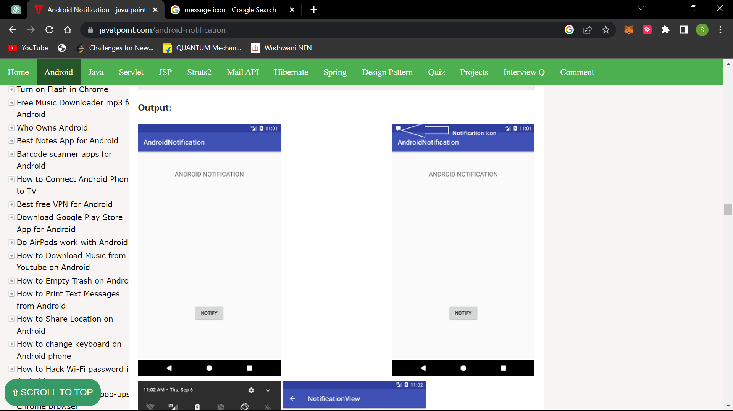 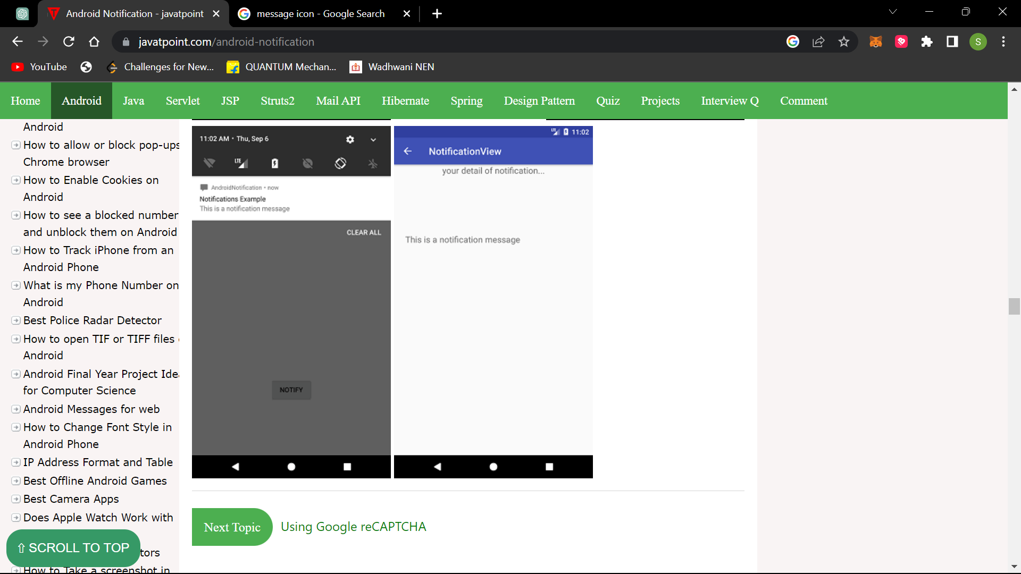 

**RESULT:**

Thus Android Application that creates an alert upon receiving a message is developed and executed successfully

Ex.no:11

**MINI PROJECT**

Date :

**AIM:**

To implement an music player application using java..

**ALGORITHM:**

* Open Android studio and select new project
* Give Project name and select next
* Then type package name and the Application name as “MUSIC APPLICATION″ and click Next.
* Go to package explorer in the lefthand side. Select our project.
* Then select the Minimum SDK as shown below and click Next.
* Then select the Empty Activity and click Next.
* Finally click Finish.
* Go to res folder and select layout. Double click the main.xml file.
* Now you can see the Graphics layout window
* Click the main.xml file and type the code below

**CODE:**

**Activity_main.xml:**

<?xml version="1.0" encoding="utf-8"?>

<RelativeLayout xmlns:android="http://schemas.android.com/apk/res/android"

xmlns:app="http://schemas.android.com/apk/res-auto"

xmlns:tools="http://schemas.android.com/tools"

android:layout_width="match_parent"

android:layout_height="match_parent"

tools:context=".MainActivity">

<TextView

android:layout_width="wrap_content"

android:layout_height="wrap_content"

android:id="@+id/songs_text"

android:textColor="@color/black"

android:text="SONGS"

android:textSize="20dp"

android:textStyle="bold"

android:padding="10dp"

android:layout_centerHorizontal="true"/>

<TextView

android:layout_width="wrap_content"

android:layout_height="wrap_content"

android:id="@+id/no_songs_text"

android:text="NO SONGS FOUND"

android:layout_centerInParent="true"

android:visibility="gone"/>

<androidx.recyclerview.widget.RecyclerView

android:layout_width="match_parent"

android:layout_height="wrap_content"

android:id="@+id/recycler_view"

android:layout_below="@id/songs_text"/>

</RelativeLayout>

**Activity_music_player.xml:**

<?xml version="1.0" encoding="utf-8"?>

<RelativeLayout xmlns:android="http://schemas.android.com/apk/res/android"

xmlns:app="http://schemas.android.com/apk/res-auto"

xmlns:tools="http://schemas.android.com/tools"

android:layout_width="match_parent"

android:layout_height="match_parent"

android:background="#0F1188"

tools:context=".MusicPlayerActivity">

<TextView

android:id="@+id/song_title"

android:layout_width="match_parent"

android:layout_height="wrap_content"

android:layout_margin="20dp"

android:ellipsize="marquee"

android:padding="20dp"

android:singleLine="true"

android:text="Title of the song"

android:textColor="@color/white"

android:textSize="20dp" />

<RelativeLayout

android:id="@+id/controls"

android:layout_width="match_parent"

android:layout_height="wrap_content"

android:layout_alignParentBottom="true"

android:padding="40dp">

<SeekBar

android:id="@+id/seek_bar"

android:layout_width="match_parent"

android:layout_height="wrap_content"

android:layout_margin="10dp"

android:backgroundTint="@color/white" />

<TextView

android:id="@+id/current_time"

android:layout_width="wrap_content"

android:layout_height="wrap_content"

android:layout_below="@id/seek_bar"

android:layout_alignParentStart="true"

android:layout_margin="20dp"

android:text="0:00"

android:textColor="@color/white" />

<TextView

android:id="@+id/total_time"

android:layout_width="wrap_content"

android:layout_height="wrap_content"

android:layout_below="@id/seek_bar"

android:layout_alignParentEnd="true"

android:layout_margin="20dp"

android:text="0:00"

android:textColor="@color/white" />

<RelativeLayout

android:layout_width="match_parent"

android:layout_height="wrap_content"

android:layout_below="@id/total_time"

android:padding="20dp">

<ImageView

android:id="@+id/previous"

android:layout_width="wrap_content"

android:layout_height="wrap_content"

android:layout_alignParentStart="true"

android:layout_centerVertical="true"

android:src="@drawable/ic_baseline_skip_previous_24" />

<ImageView

android:id="@+id/next"

android:layout_width="wrap_content"

android:layout_height="wrap_content"

android:layout_alignParentEnd="true"

android:layout_centerVertical="true"

android:src="@drawable/ic_baseline_skip_next_24" />

<ImageView

android:id="@+id/pause_play"

android:layout_width="wrap_content"

android:layout_height="wrap_content"

android:layout_centerInParent="true"

android:src="@drawable/ic_baseline_pause_circle_outline_24" />

</RelativeLayout>

</RelativeLayout>

<ImageView

android:id="@+id/music_icon_big"

android:layout_width="wrap_content"

android:layout_height="wrap_content"

android:layout_alignParentStart="true"

android:layout_alignParentTop="true"

android:layout_alignParentEnd="true"

android:layout_alignParentBottom="true"

android:layout_marginStart="107dp"

android:layout_marginTop="216dp"

android:layout_marginEnd="104dp"

android:layout_marginBottom="315dp"

app:srcCompat="@drawable/images" />

</RelativeLayout>

**Recycle_item.xml:**

<?xml version="1.0" encoding="utf-8"?>

<RelativeLayout xmlns:android="http://schemas.android.com/apk/res/android"

android:layout_width="match_parent"

android:layout_height="wrap_content"

android:background="#EFEFEF"

android:layout_marginTop="5dp"

android:layout_marginLeft="5dp"

android:layout_marginRight="5dp"

android:paddingTop="10dp"

android:paddingBottom="10dp"

xmlns:tools="http://schemas.android.com/tools">

<ImageView

android:layout_width="36dp"

android:layout_height="36dp"

android:id="@+id/icon_view"

android:layout_centerVertical="true"

android:src="@drawable/music_icon"/>

<TextView

android:layout_width="match_parent"

android:layout_height="wrap_content"

android:layout_centerVertical="true"

android:id="@+id/music_title_text"

android:layout_toEndOf="@id/icon_view"

android:padding="10dp"

android:maxLines="1"

android:ellipsize="end"

tools:text="Music"

android:textColor="@color/black"/>

</RelativeLayout>

**MainActivity.java:**

package com.example.easytutomusicapp;

import androidx.appcompat.app.AppCompatActivity;

import androidx.core.app.ActivityCompat;

import androidx.core.content.ContextCompat;

import androidx.recyclerview.widget.LinearLayoutManager;

import androidx.recyclerview.widget.RecyclerView;

import android.Manifest;

import android.content.pm.PackageManager;

import android.database.Cursor;

import android.os.Bundle;

import android.provider.MediaStore;

import android.view.View;

import android.widget.TextView;

import android.widget.Toast;

import java.io.File;

import java.util.ArrayList;

public class MainActivity extends AppCompatActivity {

RecyclerView recyclerView;

TextView noMusicTextView;

ArrayList<AudioModel> songsList = new ArrayList<>();

@Override

protected void onCreate(Bundle savedInstanceState) {

super.onCreate(savedInstanceState);

setContentView(R.layout.activity_main);

recyclerView = findViewById(R.id.recycler_view);

noMusicTextView = findViewById(R.id.no_songs_text);

if(checkPermission() == false){

requestPermission();

return;

}

String[] projection = {

MediaStore.Audio.Media.TITLE,

MediaStore.Audio.Media.DATA,

MediaStore.Audio.Media.DURATION

};

String selection = MediaStore.Audio.Media.IS_MUSIC +" != 0";

Cursor cursor = getContentResolver().query(MediaStore.Audio.Media.EXTERNAL_CONTENT_URI,projection,selection,null,null);

while(cursor.moveToNext()){AudioModel songData = newAudioModel(cursor.getString(1),cursor.getString(0),cursor.getString(2));

if(new File(songData.getPath()).exists())

songsList.add(songData);

}

if(songsList.size()==0){

noMusicTextView.setVisibility(View.VISIBLE);

}else{

//recyclerview

recyclerView.setLayoutManager(new LinearLayoutManager(this));

recyclerView.setAdapter(new MusicListAdapter(songsList,getApplicationContext()));

}

}

boolean checkPermission(){

int result = ContextCompat.checkSelfPermission(MainActivity.this, Manifest.permission.READ_EXTERNAL_STORAGE);

if(result == PackageManager.PERMISSION_GRANTED){

return true;

}else{

return false;

}

}

void requestPermission(){ if(ActivityCompat.shouldShowRequestPermissionRationale(MainActivity.this,Manifest.permission.READ_EXTERNAL_STORAGE)){

Toast.makeText(MainActivity.this,"READ PERMISSION IS REQUIRED,PLEASE ALLOW FROM SETTTINGS",Toast.LENGTH_SHORT).show();

}else

ActivityCompat.requestPermissions(MainActivity.this,new String[]{Manifest.permission.READ_EXTERNAL_STORAGE},123);

}

@Override

protected void onResume() {

super.onResume();

if(recyclerView!=null){

recyclerView.setAdapter(new MusicListAdapter(songsList,getApplicationContext()));

} } }

**Musicplayeractivity.java:**

package com.example.easytutomusicapp;

import androidx.appcompat.app.AppCompatActivity;

import android.media.MediaPlayer;

import android.os.Bundle;

import android.os.Handler;

import android.util.Log;

import android.widget.ImageView;

import android.widget.SeekBar;

import android.widget.TextView;

import java.io.IOException;

import java.util.ArrayList;

import java.util.concurrent.TimeUnit;

public class MusicPlayerActivity extends AppCompatActivity {

TextView titleTv,currentTimeTv,totalTimeTv;

SeekBar seekBar;

ImageView pausePlay,nextBtn,previousBtn,musicIcon;

ArrayList<AudioModel> songsList;

AudioModel currentSong;

MediaPlayer mediaPlayer = MyMediaPlayer.getInstance();

int x=0;

@Override

protected void onCreate(Bundle savedInstanceState) {

super.onCreate(savedInstanceState);

setContentView(R.layout.activity_music_player);

titleTv = findViewById(R.id.song_title);

currentTimeTv = findViewById(R.id.current_time);

totalTimeTv = findViewById(R.id.total_time);

seekBar = findViewById(R.id.seek_bar);

pausePlay = findViewById(R.id.pause_play);

nextBtn = findViewById(R.id.next);

previousBtn = findViewById(R.id.previous);

musicIcon = findViewById(R.id.music_icon_big);

titleTv.setSelected(true);

songsList = (ArrayList<AudioModel>) getIntent().getSerializableExtra("LIST");

setResourcesWithMusic();

MusicPlayerActivity.this.runOnUiThread(new Runnable() {

@Override

public void run() {

if(mediaPlayer!=null){

seekBar.setProgress(mediaPlayer.getCurrentPosition());

currentTimeTv.setText(convertToMMSS(mediaPlayer.getCurrentPosition()+""));

if(mediaPlayer.isPlaying()){

pausePlay.setImageResource(R.drawable.ic_baseline_pause_circle_outline_24);

musicIcon.setRotation(x++);

}else{

pausePlay.setImageResource(R.drawable.ic_baseline_play_circle_outline_24);

musicIcon.setRotation(0);

}

}

new Handler().postDelayed(this,100);

} });

seekBar.setOnSeekBarChangeListener(new SeekBar.OnSeekBarChangeListener() {

@Override

public void onProgressChanged(SeekBar seekBar, int progress, boolean fromUser) {

if(mediaPlayer!=null && fromUser){

mediaPlayer.seekTo(progress);

} }

@Override

public void onStartTrackingTouch(SeekBar seekBar) {

}

@Override

public void onStopTrackingTouch(SeekBar seekBar) {

} });

}

void setResourcesWithMusic(){

currentSong = songsList.get(MyMediaPlayer.currentIndex);

titleTv.setText(currentSong.getTitle());

totalTimeTv.setText(convertToMMSS(currentSong.getDuration()));

pausePlay.setOnClickListener(v-> pausePlay());

nextBtn.setOnClickListener(v-> playNextSong());

previousBtn.setOnClickListener(v-> playPreviousSong());

playMusic();

}

private void playMusic(){

mediaPlayer.reset();

try {

mediaPlayer.setDataSource(currentSong.getPath());

mediaPlayer.prepare();

mediaPlayer.start();

seekBar.setProgress(0);

seekBar.setMax(mediaPlayer.getDuration());

} catch (IOException e) {

e.printStackTrace();

}

}

private void playNextSong(){

if(MyMediaPlayer.currentIndex== songsList.size()-1)

return;

MyMediaPlayer.currentIndex +=1;

mediaPlayer.reset();

setResourcesWithMusic();

}

private void playPreviousSong(){

if(MyMediaPlayer.currentIndex== 0)

return;

MyMediaPlayer.currentIndex -=1;

mediaPlayer.reset();

setResourcesWithMusic();

}

private void pausePlay(){

if(mediaPlayer.isPlaying())

mediaPlayer.pause();

else

mediaPlayer.start();

}

public static String convertToMMSS(String duration){

Long millis = Long.parseLong(duration);

return String.format("%02d:%02d",

TimeUnit.MILLISECONDS.toMinutes(millis) % TimeUnit.HOURS.toMinutes(1),

TimeUnit.MILLISECONDS.toSeconds(millis) % TimeUnit.MINUTES.toSeconds(1));

}

}

**Output:**

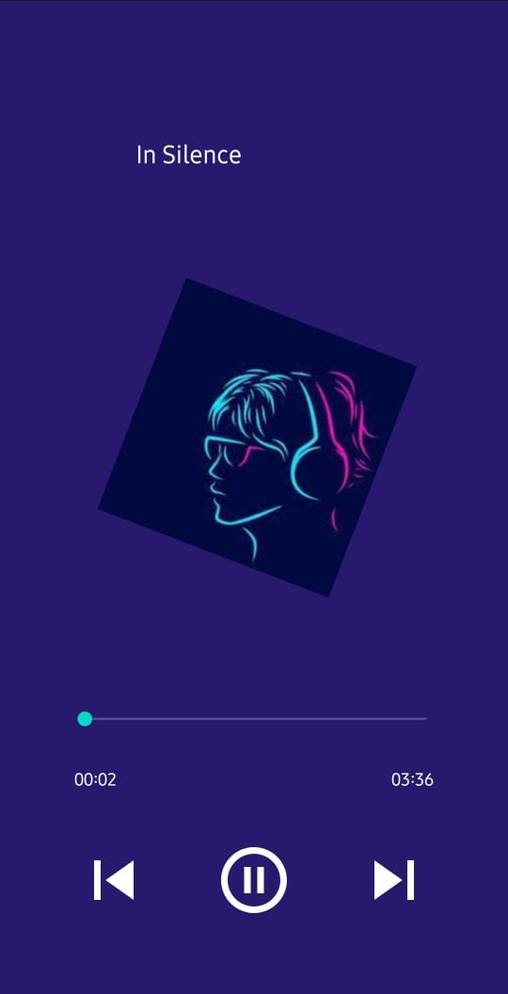

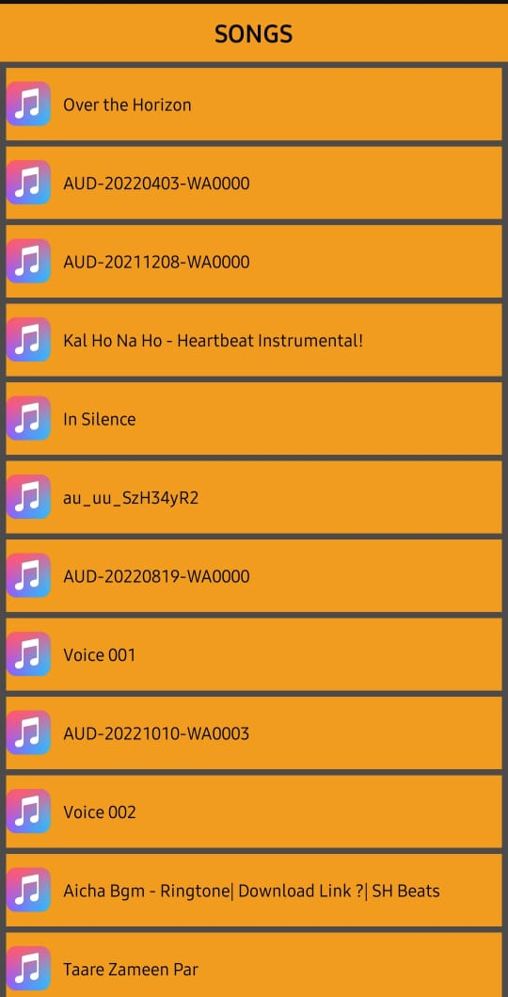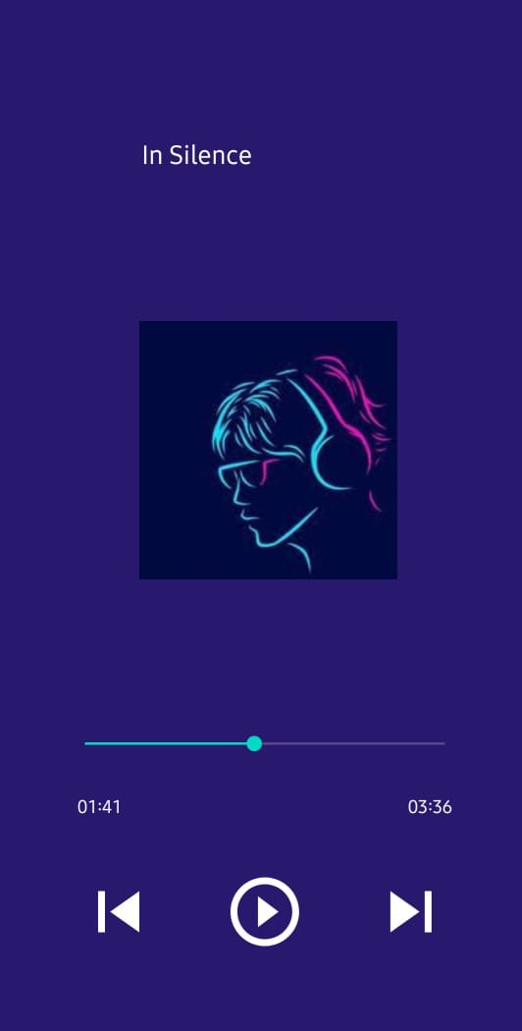

**RESULT:**

Thus Android Application that creates and music is running successfully and all the controls working fine.